Dino Karebeg’s Game Changing Game

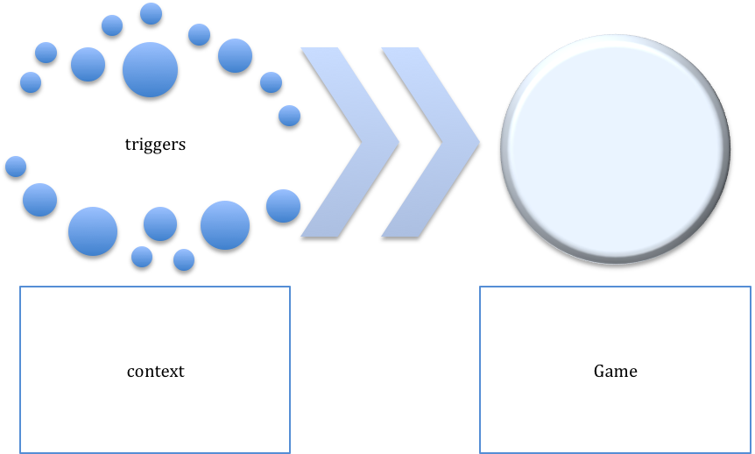

Mike Sturm’s Model for Game Changing: Explore, Excite, Examine, Execute, Assess

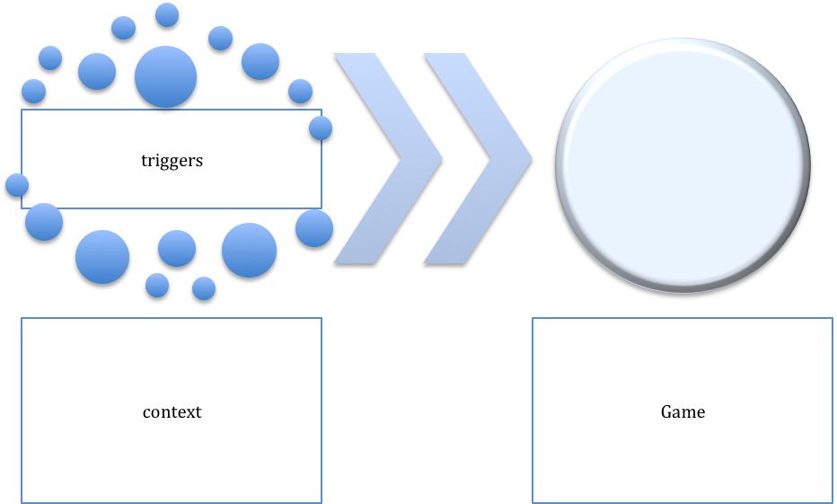

My Game Changing Game is _________________________________________________________________________

By 2050, when I am wildly successful, here is what I want it to be like:

___________________________________________________________________________________________________________

___________________________________________________________________________________________________________

The help/nudge/advice I need to get started is in these areas:

