CH MRC Sept 13 2014

Held at 1010 Emerson St, Palo Alto, CA 94301

Tim Berlyn

Michelle Brown

*Betsy Burroughs – invited Workshop leader*

Jacqueline Chan

Tammy Chan

Bill Daul

Dan Desmond

Brian Donohue

Heidi Dulay

Dan Esbensen

Mei Lin Fung

Denet Lewis

Morgan Newman

Valerie Landau

Jack Park

Kennan Salinero

Brien Shamp

Robert Stephenson

Regrets: Antonio Hernandez, Cindy Mason, Sina Nader, Majid Salehizadeh

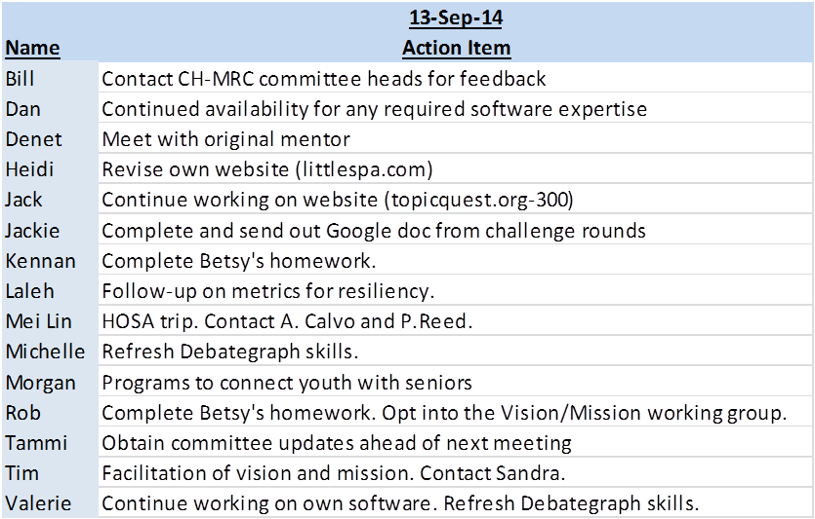

1. Mei Lin moved that the Draft Minutes of July 24 meeting be approved. Jack Park Seconded. The minutes were approved.
2. Betsy Burroughs conducted a workshop to assist us in branding. She will report back in November.
3. Laleh Shahidi, Chair of MRC presented an update and clarification on California Health Medical Reserve Corp: CH MRC
   1. As an MRC – we operate under oversight of the US Surgeon General
   2. As the first HEALTH MRC in the nation – we can be creative and innovative and move forward with our ideas and execute them
   3. We are collaborative, horizontal, participatory - there are good and bad practices for all of these – we want to pay attention to good practices of being collaborative and engaged
   4. CHMRC is a network of members and all our networks-Members can leverage the resources, the expanded audience and affiliates and associates – if aligned with CH MRC vision and mission and meant for the public benefit
   5. CH MRC is not going to be involved in legal issues or take on risks
   6. The outcome of CH MRC activities is like a kaleidoscope – each of come together in different combinations depending on the project
4. Brian Donohue presented the articles of Incorporation. Appendix 1
   1. CH MRC – we are the incubator of the kaleidoscope of ideas
   2. We will need to address issues like Trade Secret Law – what is the proper contact amongst us in terms of our networks
   3. We will file with the IRS to get approval for non profit status – We appoint Sina Nader our Finance Chair to take the lead for the filing
   4. We will have to have officers and board members - Operationally – the MRC committee is the working group to move forward on this.
5. Motion of AD Hoc Legal Committee to the Organizing Members of California Health – MRC

I, Brian C. Donohue, being duly elected as Chair of the Ad Hoc Legal Committee

of the organization in formation tentatively named California Health-MRC (“CH-

MRC”) make the following motion to the full membership of the organizing

members of California Health-MRC:

WHEREAS the Ad Hoc Legal Committee of the CH-MRC being composed of the

following members: Jack Park, Mei Lin Fung, Laleh Shahidi, Dan Desmond, Brian

Donohue met on 8-7-14 in Concord California to discuss the pending organization

of the CH-MRC, and

WHEREAS the AD Hoc Committee was joined in a conference call later with the Members of the MRC Committee Laleh Shahidi, Tim Berlyn M.D. and Sina Nader, and

WHEREAS the AD Hoc Legal Committee voted unanimously to adopt the attached Articles of Incorporation establishing a California Non-Profit Corporation under the name California Health-MRC, appointing Mei Lin Fung as Incorporator, and setting forth the legal purpose of the non-profit corporation to be the Mission Statement formally adopted by the members: Catalyzing human potential to re- imagine health,

NOW THEREFORE, upon approval of the Motion by the full membership, Mei

Lin Fung will forthwith sign and file the attached Article of Incorporation with the

California Secretary of State and complete the non-profit incorporation process forthwith.

____________________________

Brian C. Donohue, Chair

The motion was seconded by Dan Desmond.

The Motion was unanimously approved by all present.

1. Tim Berlyn outlined the 3 parallel activities underway that relate to vision and mission and asked for guidance from the group.
   1. Informal process – divergence and convergence
   2. Branding process – conducted by Betsy, report in November
   3. “Jobs to be done” approach that Mei Lin and Sandy Bates, author of “[The Social Innovation Imperative](http://www.amazon.com/The-Social-Innovation-Imperative-Challenges/dp/0071754997)” will work with CHMRC to pilot a common vocabulary for community action towards health that will synchronize us with the NQF, FQHCs, HOSA, Duke University and other community oriented initiatives.

*Discussion was lively and we agreed that all 3 serve a purpose and will continue in parallel.*

1. Jacqueline Chan proposed a working group be formed for the purpose of any revisions to our vision and mission. The motion was seconded by Tammy Chan. Votes were recorded: 9 in favor. 5 were Opposed. *(Brian Donohue, Brien Shamp, Dan Desmond had left the meeting earlier before this vote)* Tim Berlyn Operations Chair will set up the Working Group.

1. Committee Reports were noted. See Appendix 2.
   1. Jacqueline reported on the LEARNING CHALLENGE and will set up a time when a final meeting could be held.
   2. Kennan noted that there was no new learning, there are lessons for us from the Challenge Round in how to make it more of a learning experience for participants.
   3. Valerie will put all the outcomes of committee projects into CMI – The [www.SelfResiliency.com](http://www.SelfResiliency.com) initiative of the Resiliency Committee was volunteered by Laleh Shahidi to be first.
   4. Dan Esbensen will help Valerie’s programmer.
   5. Valerie will be presenting Innovations in Accreditation at the 2nd annual conference on Medical Education in Cuba
   6. Valerie will investigate a CH MRC field trip to Cuba which is a global example of community oriented health at a low cost.
2. The next Meeting will be held on Sunday October 19 from 2-5 pm at Samuel Merrit University. Thanks to Valerie Landau for hosting.

# Appendix I

Articles of Incorporation – to be obtained from Brian Donohue in soft copy.

# Appendix 2

**CH-MRC Committee Reports**

## CHC-WE (Partnerships) projects update:

* Challenge Rounds - In process of finding a time when we can have a final reflection meeting to wrap up activity. Will provide summary of findings and reflections to CHC at the following meeting.
* Networking Spreadsheet - We've been adding onto the spreadsheet as people CC us on emails. The goal is to be able to keep track of our networks and make notes for potential synergies or partnerships.

## CHC-LRN (Evaluation & Learning) projects update:

* Evaluation Software - Valerie is working on updating the software and is not yet ready to show demo in September meeting.
* Evaluation Framework - Template was created using committee objectives. However, no further work is planned for the framework until organization's mission and goals are confirmed.
* Challenge Rounds - [same as CHC-WE update]

## CHC-ZZZ committee:

* Some conversations between Denet, Brian and Sina about sleep tracking

technology, pros and cons, privacy issues, and the pros/cons of hardware as

pertaining to sleep.

* Sina’s startup will soon be releasing a white paper on the status of sleep

quality in American business. We looked at the sleep quality of 5 US

corporations with an average of 23,000 employees and a market cap of $19

billion, and have found some remarkable things. Excited to share details

within a couple of weeks, most likely.

## CHC-MRC committee:

* We are shifting our official name to California Health MRC as we were notified by the California Secretary of State that the California Health Corps was not available
* Clarification and Update on CHMRC organization is to be presented 9/13/14.